**Git Lab 2**

1. **Creates files and folders to be ignored and create .gitignore**

Opens (or creates) the .gitignore file for editing.

**Output:**

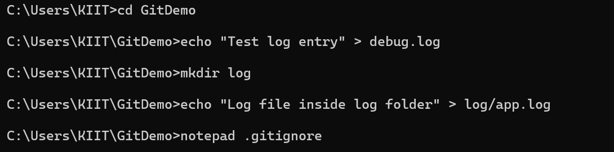

1. **Edit .gitignore file**

*.log → Ignores all files with a .log extension in any directory.

log/ → Ignores the log folder and its contents.

**Output:**

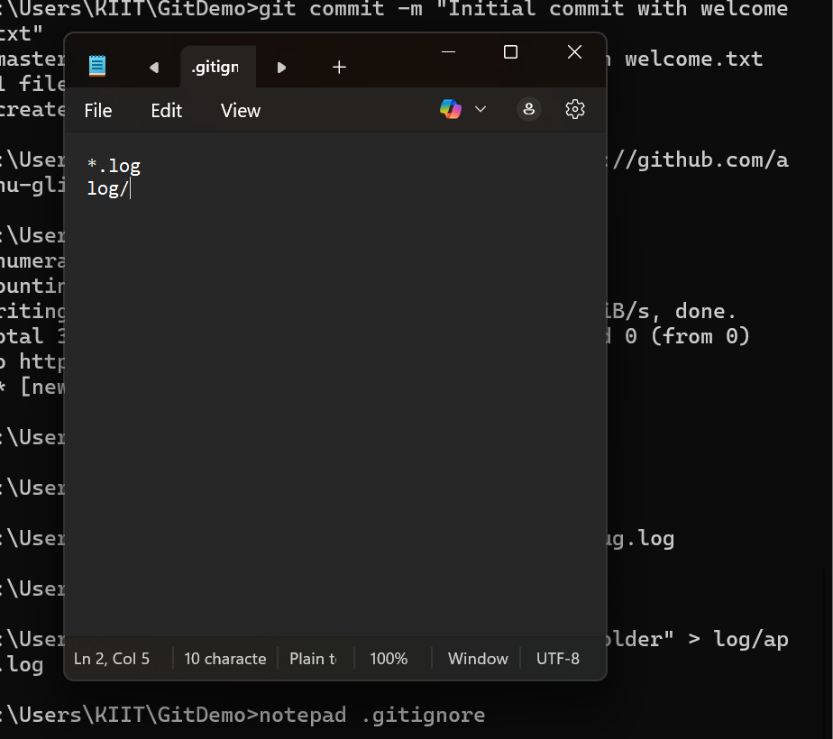

1. **Verify .gitignore effect**

The .log file and log folder should no longer appear in the “Untracked files” list.  
Only .gitignore should be shown as untracked.

**Output:**

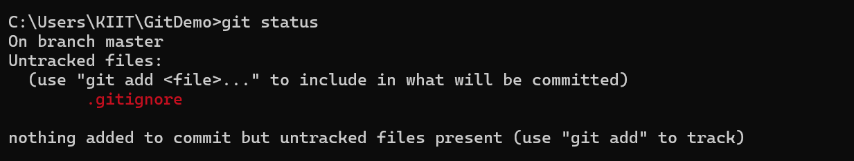

1. **Stage .gitignore and commit**

Stages the .gitignore file so it will be included in the next commit.

Saves the .gitignore file into the local Git repository.

**Output:**

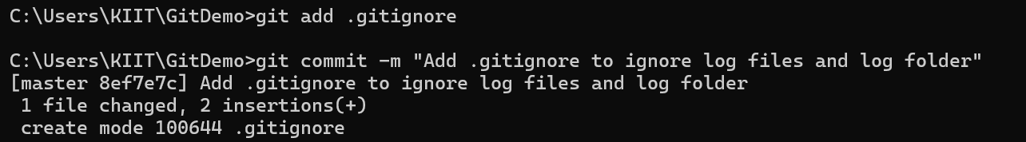

1. **Push changes to remote repository**

Uploads the .gitignore file to the remote repository so it is available for all collaborators.

**Output:**

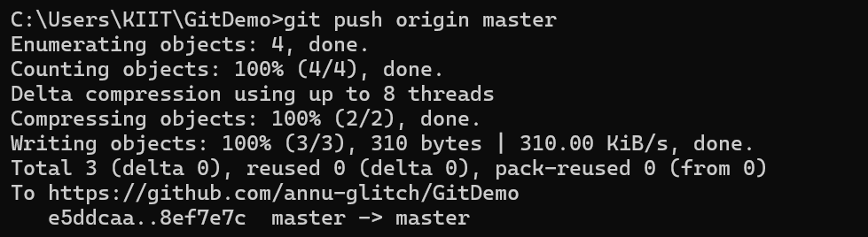

1. **Reflect changes in remote repository**

**Output:**

